**FLL TEAM 8584 – PAL-MAC RAIDER BOTS (RED)**

**SHARK 1**

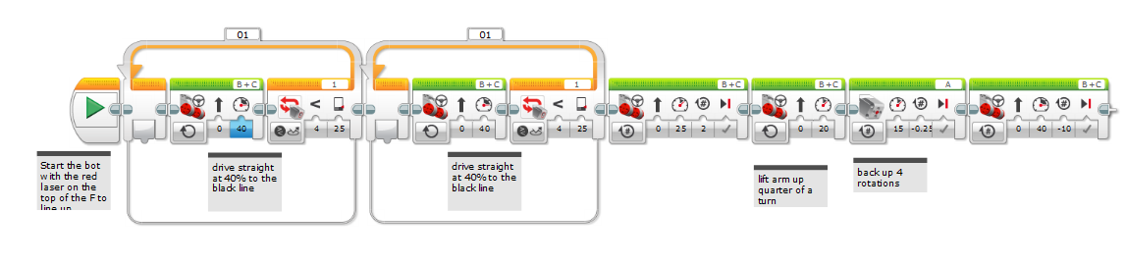

**SHARK 2**

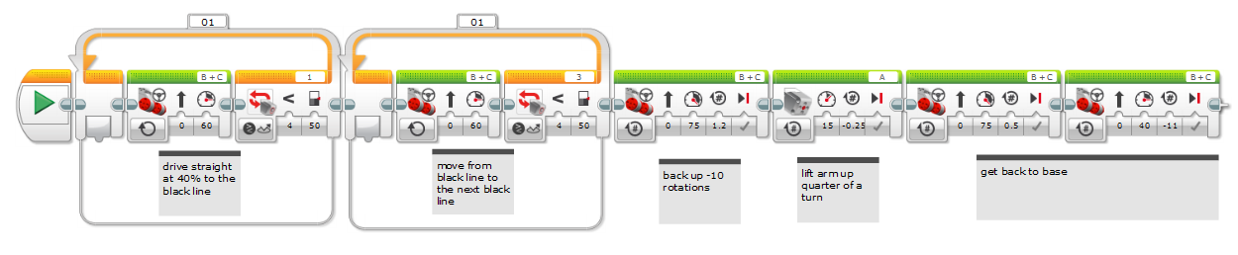

**PANDA**

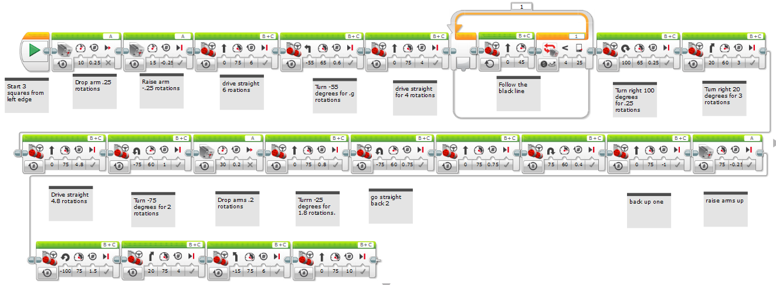

**BLINDMAN**

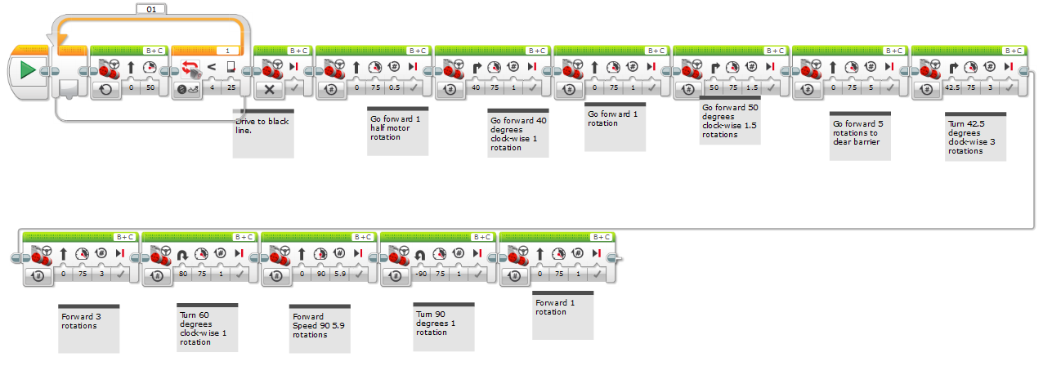

**BLINDMAN 2**

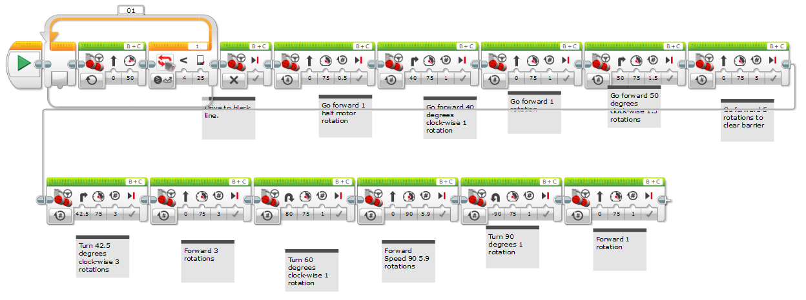

**PIG**

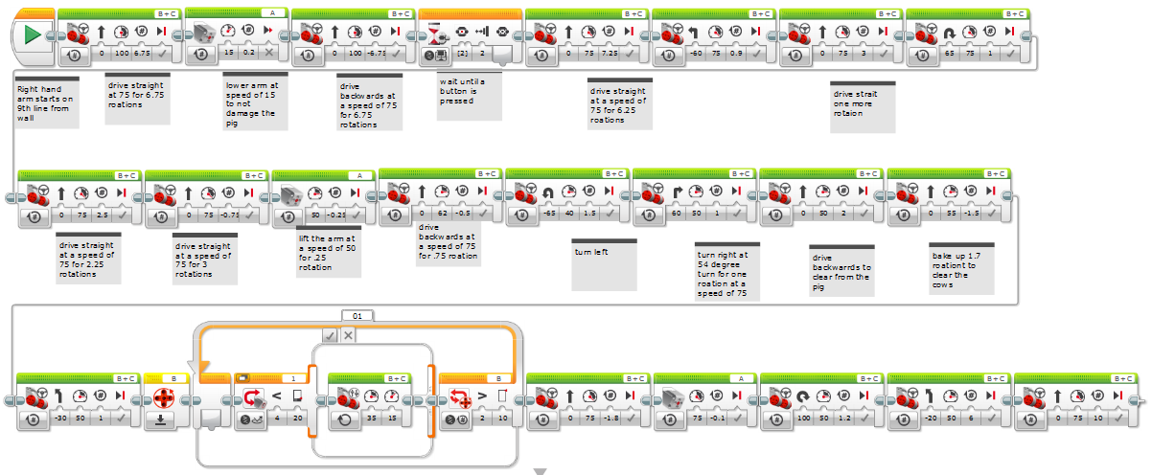

**BEEHIVE**

